Reinforcement Learning

Project Report


Faculty name: Dr. Jyoti Yadav Student name : Vanshika
Roll No.:23csu335
Semester:5th
Group:AIML-7

Department of Computer Science and Engineering
The NorthCap University, Gurugram- 122001, India
Session 2021-2022

Table of Contents
S.No |  | Page No.
1. | Project Description
2. | Problem Statement
3. | Analysis  3.1 Hardware Requirements  3.2 Software Requirements
4. | Design  4.1 Data/Input Output Description:  4.2 Algorithmic Approach / Algorithm / DFD / ER diagram/Program Steps
5. | Implementation and Testing (stage/module wise)
6. | Output (Screenshots)
7. | Conclusion and Future Scope

Project Description:
This is another very interesting problem in the OpenAI Gym to learn and experience this popular framework. In this problem, we deal with the problem of landing a lunar lander on a landing pad which is defined within the space between two yellow flags. The lander is provided with infinite fuel with four discrete actions:
- do nothing
- fire left orientation engine
- fire right orientation engine
- fire main engine
The game ends if the lander crashes or becomes still. This problem can be solved using DQN or Deep Q-Learning algorithm. To understand more about the problem and the rewards you may refer to the official documentation, Lunar Lander using OpenAI v2 - Discrete Action Space.
Problem Statement:
The fundamental problem is to develop a robust, autonomous control agent capable of successfully landing the Lunar Lander module on the designated target pad within the OpenAI Gym LunarLander-v2 (Discrete Action Space) environment.
The challenge lies in deriving a control policy that can manage the continuous, dynamic state of the lander (position, velocity, and angle) using only a limited set of discrete, high-thrust actions, to achieve a soft and stable touchdown.
Analysis:
This section details the necessary hardware and software components required to replicate the project, based on the environment and libraries used in the provided Colab notebook.
Hardware Requirements:-
CPU: A standard multi-core CPU (e.g., Intel Core i5/i7, AMD Ryzen 5/7) is sufficient for running the Gym environment and performing inference with the trained agent.
RAM: A minimum of 8 GB of RAM is recommended. The Experience Replay buffer stores a large number of transitions (e.g., 100,000), which can consume a significant amount of memory.
Software Requirements:-
Development Environment: Google Colab (or a local Jupyter Notebook installation).
Programming Language: Python 3
Core Libraries:
  - gym: The OpenAI Gym library, used to create and interact with the LunarLander-v2 environment.
  - pytorch (torch): The deep learning framework used to build the Q-Network and Target Network, compute gradients, and optimize the model.
  - numpy: A fundamental library for numerical operations, used for handling states, actions, and rewards.
  - collections.deque: Used to implement the finite-memory Experience Replay buffer efficiently.
  - matplotlib.pyplot: Used for plotting the agent's performance (rewards per episode) over time.
Design:
This section outlines the data flow of the system and the algorithmic architecture of the Deep Q-Network (DQN) agent.
Data/Input Output Description:-
The agent-environment interaction is defined by a clear input-output loop:
- Input (State Space): At each time step, the environment provides the agent with an observation of the current state. This state is a continuous 8-dimensional vector containing:
  - X-coordinate
  - Y-coordinate
  - X-velocity
  - Y-velocity
  - Angle
  - Angular velocity
  - Leg 1 contact (1.0 if touching, 0.0 otherwise)
  - Leg 2 contact (1.0 if touching, 0.0 otherwise)
This 8-dimensional vector is the direct input to the agent's neural network.
- Output (Action Space): Based on the input state, the agent's neural network computes Q-values for all possible actions. The epsilon-greedy policy selects one action from the discrete 4-dimensional action space:
  - 0: Do nothing
  - 1: Fire left orientation engine
  - 2: Fire main engine
  - 3: Fire right orientation engine

Algorithmic Approach / Algorithm / Program Steps:
The problem is solved using a Deep Q-Network (DQN). This algorithm learns an optimal policy by training a neural network to approximate the action-value function, Q(s, a). The goal is to find a Q function such that Q(s, a) represents the maximum expected future reward an agent can get by taking action a in state s and acting optimally thereafter.
Core Components:-
- Q-Network (Policy Network): A feed-forward neural network that takes the 8-dimensional state as input and outputs a 4-dimensional vector of Q-values (one for each action).
- Target Network: A second neural network with the exact same architecture as the Q-Network. Its weights are "frozen" and only periodically updated (copied) from the Q-Network. This provides a stable target value for the loss calculation, preventing the "moving target" problem and stabilizing training.
- Experience Replay Buffer: A memory structure (a deque) that stores past experiences as tuples: (state, action, reward, next_state, done). Instead of learning from experiences as they happen, the agent samples random mini-batches from this buffer. This breaks the correlation between consecutive experiences, improving learning stability.
Algorithm Steps (How it learns):
- Setup:
  - Create the memory buffer.
  - Create the main Q-Network.
  - Create the Target Network (as a copy of the main one).
  - Choose settings like learning rate, batch size, and exploration rate (epsilon).
- Training Loop (for each game/episode):
  - Start a new game and get the first state s.
  - Loop (for each step in the game):
    - Choose Action: Use an "epsilon-greedy" policy. This just means:
      - With probability epsilon , pick a random action (this is "exploration").
      - Otherwise, ask the main Q-Network for its predictions and pick the action with the highest Q-value (this is "exploitation").
    - Play: Take that action and see what happens. The game gives back a new state s', a reward r, and a done flag (is the game over?).
    - Memorize: Store this whole experience (s, s', a, r, done) in the memory buffer.
    - Learn :
      - Grab a random mini-batch of old memories from the buffer.
      - For each memory in the batch, calculate the "target" value. We ask the Target Network what it thinks the best score from the next state is.
      - Calculate the "predicted" value. We ask the Main Network what score it thought it would get for the action it actually took.
      - Gradient Descent: We calculate the difference (the "loss" or "error") between these two values. Then, we nudge the weights of the Main Network to make its prediction a little bit closer to the target.
    - Update Target: Every few steps, we copy the Main Network's new, smarter weights over to the Target Network to keep it up-to-date.
    - Update s s'. If done is true, end the episode.
  - Decay Epsilon: After each episode, lower epsilon slightly. This makes the agent explore less and trust its own judgment more as it gets smarter.
Implementation and Testing (stage/module wise):
The code in the notebook is broken into a few logical parts:
- Module 1: The Q-Network (QNetwork class):-
  - What it is: A standard PyTorch class that defines the "brain's" architecture.
  - Structure:
    - Input Layer: 8 nodes (for the 8 state numbers)
    - Hidden Layer 1: 64 nodes (with ReLU)
    - Hidden Layer 2: 64 nodes (with ReLU)
    - Output Layer: 4 nodes (one for each action's Q-value)
  - Testing: It gets tested every time the agent uses it to act or learn.
- Module 2: The Replay Buffer (ReplayBuffer class):-
  - What it is: A class for the agent's memory, built using collections.deque.
  - Methods: add() to put a new memory in, and sample() to get a random batch for learning.
  - Testing: It's tested by the main training loop, which constantly adds to and samples from it.
- Module 3: The DQN Agent (Agent class):-
  - What it is: This is the main "agent" class that ties everything together.
  - What it does: It holds the two networks (main and target) and the memory buffer. It has the main methods:
    - step(): Called every step to save the memory and decide when to learn.
    - act(): Chooses an action using the $\epsilon$-greedy policy.
    - learn(): Runs the learning process (sampling, calculating loss, and updating the network).
  - Testing: This is the main object we're testing during the training run.
- Module 4: Training (dqn function):-
  - What it is: This is the main script that starts the environment and the agent, then runs the training loop (see 4.2) for a set number of episodes.
  - Testing: We test this by watching the scores. The environment is "solved" when the agent gets an average score of +200 over 100 episodes in a row. When it hits this, the loop stops and saves the trained model.
Output-
Graph-
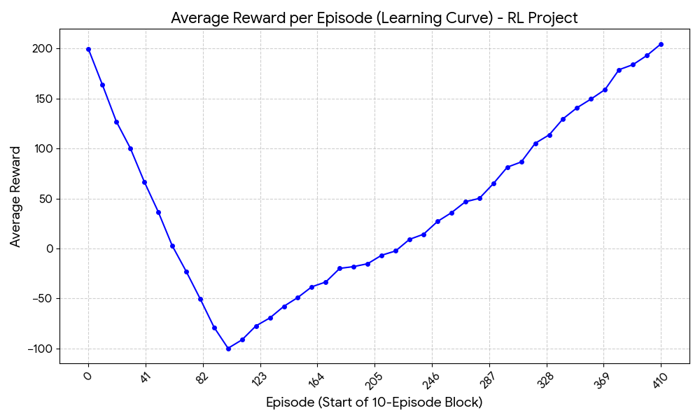

Conclusion and Future Scope:
Conclusion:-
So, in the end, it worked! This project successfully shows that a DQN can learn to solve a pretty tricky physics-based control problem. By using a neural network as its "brain" and stabilizing its learning with Experience Replay and a Target Network, the agent went from total rookie to pro pilot.
Starting with zero knowledge, it learned how to fire its thrusters to control its speed and angle, navigate to the landing pad, and touch down softly. Seeing it consistently score over +200 proves the policy it learned is robust and effective.
Future Scope:-
We got it working, but there are always more things to try to make it even better:
- Better Algorithms:
  - Double DQN: We could implement "Double DQN," a common upgrade that helps prevent the agent from getting over-optimistic about its Q-value predictions.
  - Dueling DQN: This is another enhancement where the network separately estimates "how good is this state?" and "how much better is this action?" which can speed up learning.
  - Prioritized Experience Replay (PER): Instead of sampling random memories, we could teach the agent to focus on "surprising" or "important" memories where its predictions were really wrong.
- A Harder Problem:
  - We could try the LunarLanderContinuous-v2 version of the game. In that one, the thrusters aren't just on/off—you have to choose a continuous thrust value (e.g., 0.0 to 1.0). This requires a different, more advanced algorithm like DDPG or PPO.
- Better Tuning:
  - We could spend more time "tuning the knobs"—messing with the learning rate, network size, memory buffer size, etc. A more systematic search for these "hyperparameters" could lead to faster training or an even higher final score.

